Project name: Quiz Game

Doctor's name: Hader Hussain

Team ID: GEN_112

|  |  |
| --- | --- |
| Name | ID |
| محمد احمد محمد زكريا | 20201700661 |
| عبد الرحمن محمد يوسف الوكيل | 2020170192 |
| محمد محمود عبد الرحمن علي | 20201700735 |
| شعيب علي إسحاق داود | 20201701274 |
| عبد الرحمن فايز حسن مصطفي | 20201700479 |
| عبد الرحمن مجدي فتحي محمد | 20201700480 |
| عبد الرحمن محمد محمود حسين | 20201700486 |

**Project Screenshot:**

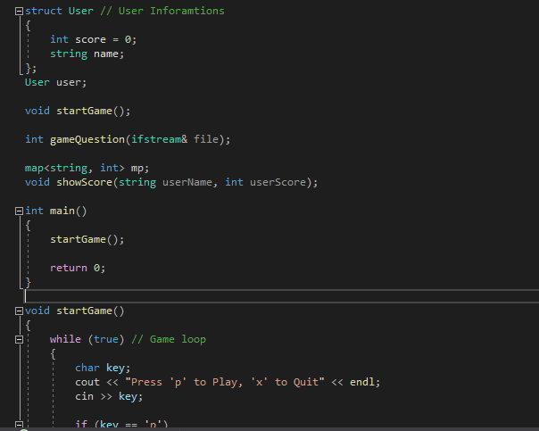

----------------------------------------------------------------------------

1) At first the used libraries were:

•fstream

•string

•map

2) the user info was saved in struct called “user”, it includes the name and the score of each player

3)the game was divided among three functions

First:” start game”

Second:” game question”

Third:” show score”

___________________________________________________

**1)_ Start game:**

This function enable the player to play by typing the letter “p” or to close the game by letter “x”, if the player chooses to play then he will be able to choose the field .

The game consists of 4 main fields.

1)science

2)technology

3)sports

4)movies

Each field consists of 2 levels and each level consists of 5 questions.

The player is awarded for each correct answer.

**2) Game question**

This function is responsible for reading the “already written questions” in their files and the shows them on the console.

The player must type an answer from the four choices.

(a, b, c, d).

If the choose choice was right the player will be awarded and “correct answer!!” Will appear, if not

“Sorry wrong “will appear and he will lose.

There is a counter named “correct” which counts the score of the player.

**3) Show score**

The function depends on map to arrange the names of the player with their scores.

The highly ranked players are those how answered the 10 questions correctly.

-------In the end we wish you enjoy our QUIZ GAME!!------